Week 6 soil recap

**Lecture 1**

Soil is important for “normalizing” water content, but has a hard time dealing with large quantities of water suddenly and in rare bursts.

Soil colloids are organic and inorganic matter with very small particle sizes and correspondingly large surface area per unit mass. They are important to water absorption, retention, availability of soil nutrients, and shrink/swell properties within the soil. Colloids tend to have negative charges. There are four categories:

1. Crystalline silicate clays
2. Noncrystalline silicate clays
3. Iron and aluminum oxides
4. Organic matter

Lets look at clay again. It is Extremely small, and called a “secondary mineral”. Sand and silt are both primary minerals. Clay is formed through the physical and biogeochemical weathering of primary rocks. It has 2 basic building blocks: silica (Si) tetrahedron and aluminum (Al) octahedron. These building blocks form sheets and layers.

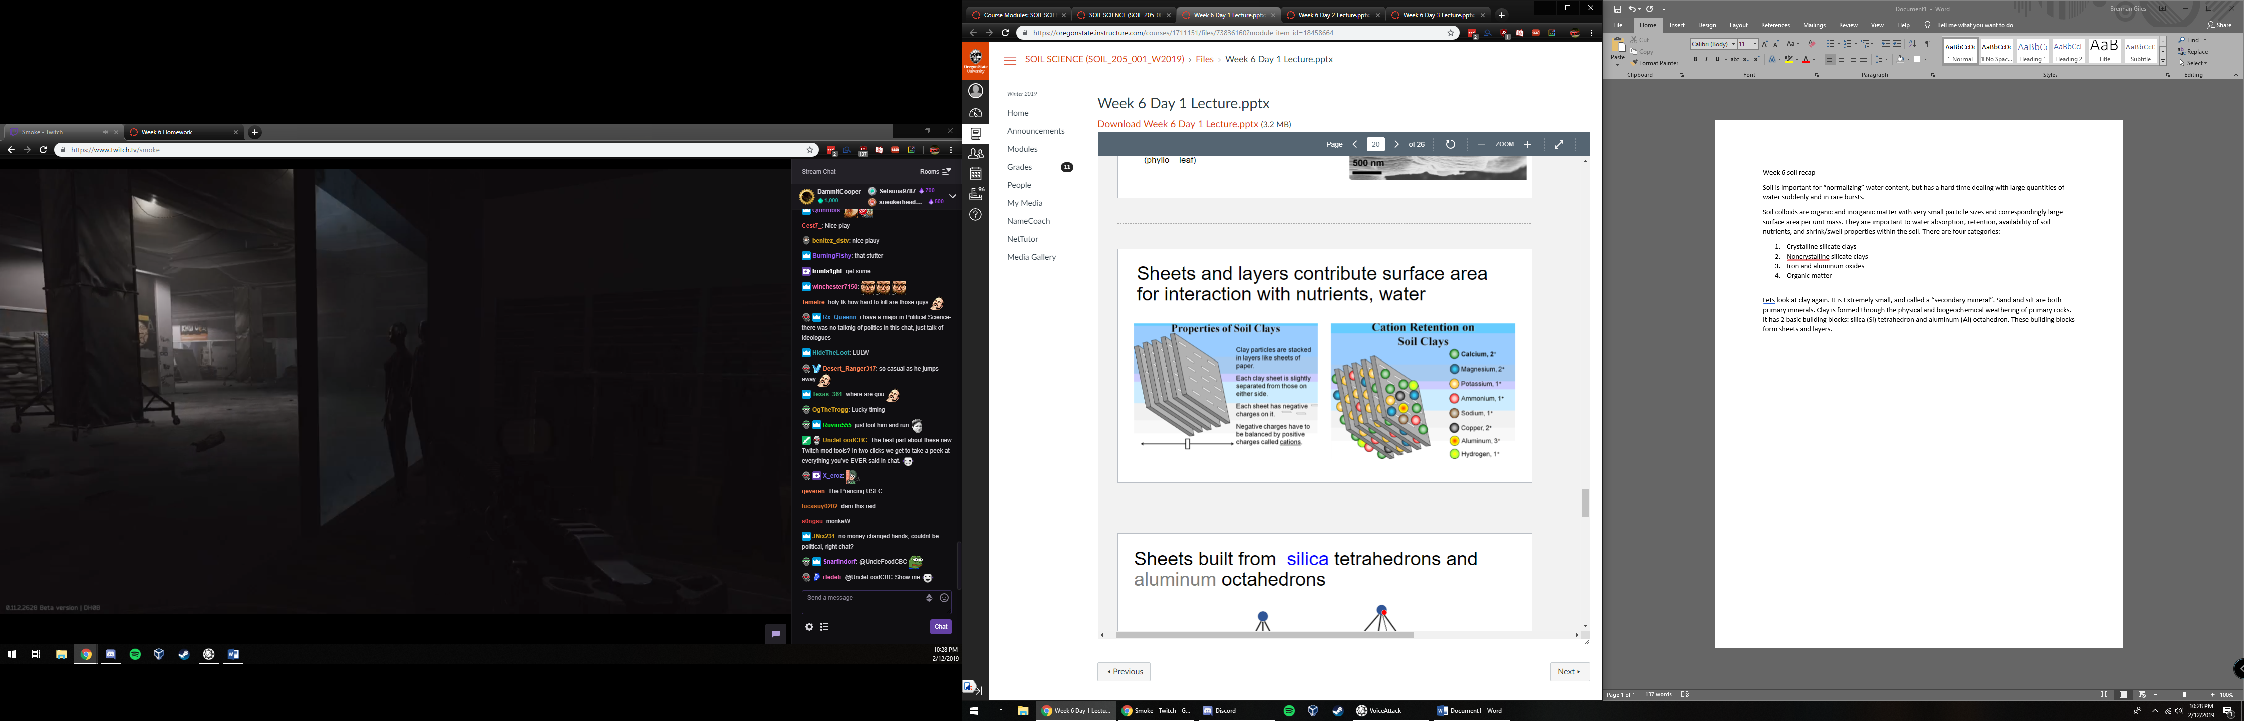

**Lecture 2**

There are two sortings of crystalline silicate clays, 1:1 and 2:1. the first is 1 tetrahedral sheet to 1 octahedral sheet, which allows H-bonding between layers and no water/ solutes in between the two sheets. The second looks like an Oreo with 2 tetrahedral sheets and 1 octahedral sheet. It does not allow H-bonding between layers however water/ solutes can move in between the sheets.

ISOMORPHEOUS SUBSTITUTION

Isomorphous ~ equal shape and size

Isomorphous substitution is the replacement of one ion for another of similar size, within the crystalline structure of the clay, at the time of crystal formation. This changes the total charge and location of the charge on the mineral. It can determine soil fertility, soil water relationships, and swelling. Which elements can substitute depends on charge and size, and keep in mind that substitutions almost always have less positive charge afterwards.

All Colloids have PH-dependent charge!

2:1 silicate clays have permanent charge.



Why do different clays form from the same primary mineral sometimes? Ions present and their concentration in solution at the time of crystallization has an impact, as do weathering conditions such as temperature and rate of leaching.

Kaolinite – sheets of silicon tetrahedra and aluminum octahedra linked by shared oxygen atoms. No isomorphous substitution and edge charge only with this!

Kaolinite is a 1:1 clay with no shrink swell properties. It is a product of acid weathering.

2:1 silicate clays have three key groups:

Smectites, vermiculites, and micas (also oddball chlorites)

Smectites have large inner surface area, and are unstable (weather to something else) under low ph and high moisture. It has the most shrink-swell action of all clays and is nutrient rich.

Vermiculite has high layer charges in BOTH sheets, has limited shrink-swell, is the most nutrient rich out of all of them, and is stable under moderate to low soil ph. Common in midwestern US.

Mica has strong surface charge but is fairly nutrient poor and non swelling. It is stable under moderate to low ph and common in midwestern us.

Chlorite is iron rich, has low nutrient supply capacity, has restricted swelling, nutrient poor, and common in sedimentary rock – derived soil.

**Lecture 3**

Fun fact: smectite would be bad to build a home on.

Fun fact: a well drained soil under a rain forest in brazil with significant amounts of silicate clay is most likely going to be kaolinite

Noncrystalline silicate clays (amorphous)

Composed of AL, Si, and O, but disordered

Allophane and Imogolite

Characteristic of Andisols (formed from volcanic ash) and have lots of charge, high water-holding capacity, and strong absorption of phosphate.

Iron and aluminum oxides have low charge, low plasticity and stickiness.

PH dependent charge: low PH means high concentration of H+, little or no available charge. As ph increases hydrogens come loose and can be exchanged for other cations.

Organic Matter

Smallest of colloids, with HUGE surface area. Lots of ph-dependent charge and water holding capacity. Low stickiness, non cohesive and easy to detect by color (black).

